Human Resources in Intensive Care:
Do doctors and nurses make a difference to patient outcomes?

Abstract
Objectives: To investigate whether the size of the clinical workforce—nurses and doctors—can be shown to have an impact of the survival chances of critically ill patients both in the intensive care unit and in the hospital.
Background: Intensive care outcomes vary across the UK in ways that are not as yet well understood. The literature suggest that some of the variation might be related to workload, medical cover, or nurse staffing but previous studies have usually estimated the impact of these variables separately. This study brings the three potential sources of variation together into one analysis.
Data: Two high quality national data sets provided data on patients and units. Information about patients, including the outcome of the hospital episode, came from the Intensive Care National Audit and Research Centre (ICNARC), based in London. Information about the units came from a survey of all ICUs in England conducted by the Audit Commission in 1998. Data were matched for 69 units and information on 43,859 patients was included in the analysis.
Design: A cross-sectional, risk adjusted observational study.
Methods: Multivariate, multi-level logistic regression.
Results: After controlling for patient characteristics and the workload of the unit we found that higher numbers of direct care nurses per bed on the unit’s establishment and higher numbers of consultants per bed were associated with higher survival rates. There was also an interaction between the number of nurses and patient's risk of mortality, suggesting that nursing staff availability has the greatest impact on those at greatest risk of death. The clinical workforce in intensive care had a greater impact on ICU mortality than on hospital mortality.
Conclusion: This study suggests that the availability of medical and nursing staff are both associated with the survival of critically ill patients and suggests that future studies should shift from the traditional focus on single professions to an emphasis on the resources of the health care team.
Key words: Intensive care units, nursing, physicians, mortality, observational studies, multi-level modelling

Introduction
“Comprehensive critical care is a 24-hour a day, 7 day a week service that requires the deployment of a sufficient number of appropriately trained and experienced specialist and support staff. Competencies are more important than professional boundaries in the delivery of a safe, efficient and cost-effective service…Human resource issues lie at the very heart of the provision of critical care services. No amount of equipment can compensate for the lack of appropriately trained staff.” Comprehensive Critical Care: A review of adult critical care services. Department of Health. 2000
This study investigates whether the availability of nurses and doctors has an impact on patient survival in intensive care using two high quality national datasets collected in England around March 1998. The aim is to determine whether human resources can explain some of the variation in intensive care outcomes that remains after controlling for other important variables.
Of course in the context of health policy, this question is of great importance in itself. More generally, it is often difficult to test the effects of human resource practices on organizational outcomes, at least in part because of the problems of measuring outcomes. In this case, we have a clear and unambiguously important outcome measure: patient mortality. Hence, we are contributing to the wider literature on human-organizational interactions.

What is already known
A recent review of the literature on the impact of nursing resources on patient mortality in intensive care identified ten studies, of which only three were able to reject the null hypothesis of no relationship.(1-4) In the only UK study, Tarnow-Mordi et al. found that patients who were treated at times when the ICU workload was high were about twice as likely to die as those who were admitted during relatively quiet periods.(2) Previous research on adverse events has found evidence that patients are at risk of developing complications in intensive care units when nurse-patient ratios are low.(3-12) Some of the adverse events discussed in these reports (e.g., bloodstream infection, pneumonia) have a known association with mortality. In sum, there are suggestions in the literature that there might be an association between nurse staffing in ICU and outcomes, but the evidence is not as yet compelling. There are inconsistencies in the results and there are a number of methodological problems that often characterise observational research using administrative datasets.
Studies of the medical contribution to patient outcomes in intensive care have focused on the role of the intensivist and on the relative effectiveness of “open” and “closed” ICUs. In open units, which predominate in the USA, patients are cared for by their primary physician. Closed units, where an intensivist or team of intensivists provides care, is more common in Europe.(13) There is now good evidence that the closed model and the use of an intensivist are associated with lower rates of mortality. (14)
An Audit Commission study of intensive care in England and Wales found no association between the level of medical staffing and skill mix and APACHE II adjusted mortality, but the pattern of cover by consultants did have an effect.(15) Patients’ survival chances seemed to be better in units where consultants worked a week on/week off rota. This was the only measure of human resources that the Audit Commission found to be significant.
In a review of the literature on organisational factors in intensive care, Carmel and Rowan identified 13 studies under the heading “volume and pressure of work”, using a range of measures of workload.(16) The number of admissions per month was not significant in a study by Jones and Rowan, but a later study showed that the number of admissions per week was positively associated with improved rates of hospital mortality.(17, 18) Lower levels of night and premature discharges were linked to improving patients' survival chances.(19) Shortell showed that lower levels of diagnostic diversity improved mortality, but diagnostic diversity had no impact in a later study conducted in Brazil.(20, 21) So, although workload is believed to be an important factor in mortality, the concept has been operationalised in many different ways and the evidence is contradictory.

Data
The ICNARC case mix programme is a comparative audit of patient outcomes in a sample of ICUs in England, Wales and Northern Ireland. The sampled units are representative of the population in terms of spread, unit size and unit type (university v. district general). A subset of the data for the six months before and after March 1998 which had been collected prospectively was merged onto data on 69 ICUs surveyed by the Audit Commission. The matched datatset contained information only on ICUs in England. We use two dichotomous dependent variables: whether or not the patient survived their stay in ICU and whether or not the patient survived their stay in hospital. Analysis was restricted to the subset of patients who stayed in the ICU for at least eight hours. Four ICUs were omitted from the analysis due to missing data, giving a basic sample of 65 ICUs and 40,408 admissions. This was further reduced in the multivariate analyses by patient-level missing data; numbers of cases in each analysis are shown in the relevant tables.

Risk Adjustment
There are a number of risk adjustment models for use with critical care patients. The most widely used in the UK is probably the APACHE II model, for which UK coefficients were published in 1990.(22) Recently, ICNARC have recommended the use of a new model (IM), which we adopt.(23) The distribution of the log odds of the IM-predicted probability of mortality is shown in Figure 3.
[Figure 3 about here]

Independent variables
Data on the main independent variables came from the Audit Commission's survey of all ICUs in England and Wales, on which the report Critical to Success was based.(15) Key independent variables derived from this dataset are described below.

Human resource variables

Number of direct care nurses per bed: The Audit Commission data on the number of nurses per bed in each unit were disaggregated into direct care and supernumerary staff. It is important to note that this variable counts the number of full-time equivalent nurses on the permanent staff of the ICU on one specific date, not the number available for duty when any particular patient is admitted. Variation in this number across units might therefore reflect variation in the nurse-to-patient ratios that operate in different ICUs, but it might also reflect differences in the reliance on nurses from elsewhere in the hospital, from agencies or the staff bank to maintain adequate levels of staffing. The distribution of nurses across different units is shown in Figure 4, which clearly demonstrates that only a minority of units in the UK were able to claim a one nurse per patient ratio in 1998.
Number of consultants per bed: Similarly, units reported to the Audit Commission the number of consultants in any speciality that have one or more weekly fixed notional half days (NHDs) for critical care clinical sessions. We standardise this total by the number of beds in the unit. Fifteen units had no such consultants, with the mean being 0.49.
[Figure 4 about here]
Intensivist: The survey asked whether one or more consultants worked all the time in the unit (and related CCUs) with no other clinical commitments. The majority of the units in this analysis (60) did have specialist cover of this kind.

Workload variables
We used a number of variables designed to measure the pressure of work experienced by the staff of the ICU.
- Proportion of beds in the ICU that were occupied at the time of each patient's admission.
- The mean number of transfers in and out of the unit per day.
- Average length of stay of patients in the ICU, measured in hours.
- Mean APACHE II scores of other patients in the unit at the time of admission.
The first two of these items captures business in terms of occupancy and movements of patients in and out of the unit. The latter two units are intended to measure variation in demands on the unit in terms of the level of sickness of the patients that it treats.
[Table 1 about here]
We also included interactions between the number of nurses and the number of consultants and the log odds of the IM probability of patient mortality to see whether the impact of staffing differs depending on the degree of severity of the patient's illness. Correlations among all these variables are show in Table 1.

Statistical analyses
All our analysis was carried out using R version 2.4.(24) The multilevel logistic regression analyses were carried out using the "lmer" function that is part of the lme4 package.(25) The basic model that we used can be represented by the following equation:
where i indexes patients, j indexes units, there are k explanatory variables in the model, p_{i} is the probability of death, and the following conditions are assumed:
The estimates of the effects of the explanatory variables (b_{k}) are, therefore, interpreted in the same way as standard logistic regression estimates.

Results

Descriptive statistics
Of the 40,408 patients in this study, 6776 (17%) died in the ICU where they were being treated. A further 4654 (11.5%) died in hospital after leaving the ICU, with 593 (1.5%) patients being lost to follow up. The observed crude mortality rates in the units varied between 10 per cent and 36 per cent, while the hospital mortality rates lay between 19 per cent and 59 per cent. This variation could not be entirely explained by variation in patient risk factors. The correlation between the ICU and hospital mortality rates was .92.
The graph in Figure 4 shows that only a minority of units have enough nurses on their permanent payroll to maintain a one patient per nurse ratio over three shifts, with allowance for sickness and holiday leave. In fact, only four have seven or more nurses per bed, which is generally accepted as the number of nurses needed to maintain this staffing level.

Multivariate analyses
The results of our multivariate analyses are shown in Table 2 (ICU mortality) and Table 3 (hospital mortality). The first column in each table shows the results with only the main effects of the independent variables included. However, as we believe that the effect of staffing might depend on the severity of a patient's illness, in the second column we add an interaction between the number of nurses and IMlo (the risk adjustment variable), while in column III we add an interaction between the number of consultants and IMlo.
[Table 2 and Table 3 about here]
Considering first the impact on ICU mortality, shown in Table 2, we can see that the risk of mortality is significantly increased by having a higher proportion of occupied beds in the unit, by having a larger number of transfers in to and out of the unit and in units in which patients tend to have longer stays. On the other hand, the number of direct care nurses and consultants both significantly reduce the risk of mortality. In the second column we add the interaction between patient's mortality risk and the number of nurses. The interaction effect is also negative and significant, implying that the reduction in mortality risk from having more nurses is larger for patients who are sicker. In column III, however, we can see that the same interaction is not significant when it involves the number of consultants. The result for nurses is shown graphically in Figure 5. Using the results in column II, we can calculate that the effect of increasing the number of nurses from four to six is to reduce the probability of mortality for patients with an IM log odds of mortality of -3 from .0182 to .0181. This represents approximately one extra death for every 20,000 patients. However, the real importance of these results is that this effect is so much larger for those patients who have a high IM log odds of mortality. If we look at patients with an ICNARC Model predicted log odds of mortality of 2, then the reduction in the probability of mortality in going from four to six nurses is from .72 to .67. About five per cent of ICU admissions have IM log odds of mortality at least this high, so this represents a significant number of patients each year.
[Figure 5 about here]
In Table 3, we see a broadly similar pattern of results for the effects on hospital mortality. Again, the number of nurses and the number of consultants have a negative association with the risk of mortality. The estimated magnitude of these effects, though statistically significant, is smaller the corresponding estimates of their effects on the risk of mortality in the ICU. However, neither of the interactions is statistically significant in this table, implying that this association does not depend on the patient's risk of mortality.

Discussion

Principal findings
This study investigated whether the size of the clinical workforce—nurses and doctors—was associated with the survival chances of critically ill patients both in the intensive care unit and in the hospital. The most significant findings are that, controlling for patient characteristics and the workload of the unit, higher numbers of direct care nurses per bed on the unit’s establishment and higher numbers of consultants per bed were both associated with higher survival rates. High workload (measured as proportion of occupied beds and mean daily transfers) was associated with higher mortality. The average APACHE II score of the other patients in the unit, which was also included as a measure of workload was not significant.
There was also a statistically significant interaction between the number of nurses and patient's risk of mortality, suggesting that nursing staff availability has the greatest impact on those at greatest risk of death. The clinical workforce in intensive care had a greater impact on ICU mortality than on hospital mortality.

Strengths and weaknesses of the study
The use of two high quality national data sets is a strength of this study. Data from the Intensive Care National Audit and Research Centre (ICNARC) enabled us to estimate models of ICU and hospital mortality using sophisticated methods of risk adjustment, and to control for an important source of workload; the proportion of beds that were occupied at the time the patient was admitted. Data on characteristics of the unit collected by the Audit Commission in 1998 and a merged dataset with information on 69 units and 43,859 patients was constructed. Multi-level logistic regression was used to analyse the outcomes of their admission. The large number of units and patients analysed in this study, as well as the use of appropriate methods for the structure of the data are additional strengths of this study.
But there are also weaknesses. The data are cross-sectional which limits the extent to which causal claims can be made. The data are also several years old. However, this is less important to us because we set out to test hypotheses about a theorised relationship between human resources and organisational performance which was not temporally or geographically bounded. Changes in the distribution of staff across units since the data were collected will mean that the results are probably less useful for practical purposes such as workforce planning, but the results suggest that managers and policy makers need to consider human resources as key to quality and safety in UK ICUs.

Implications and future research
Taken together these findings suggest the need to study the whole team in ICU. There is a large literature on the nursing contribution to patient outcomes which focuses on the size and level of qualifications of staff. There is also a large literature on the medical contribution to ICU outcomes. We argue that future studies need to consider these two groups, as well as other members of support staff at the same time. Nurses and doctors, in particular, may in some clinical settings be substitutes for each other, so that units that are short of for example, may compensate by hiring more nurses. This is supported by ethnographic evidence of how closely clinicians from different professional backgrounds work together in this setting. Future studies also need to need to control adequately for workload. The nurse-to-patient or physician to bed ratio does not make sense without including controls for the throughput of the unit as well as amount of care that each patient needs. Further research is on the workforce is urgently required to guide decisions about staffing in a variety of health care settings to ensure patient safety as well as equity and cost-effectiveness across the whole system. Perhaps the major weakness of this study is that it is not theoretically driven. Rather it tests a rather simple model of human resources. However, it does demonstrate a relationship between those inputs and perhaps the most important measure of a hospitals performance—whether or not patients survive. This study has a number of strengths, including the quality of the data and appropriateness of the statistical analysis and we believe that the baseline model we have produced will be useful in testing more complex models of team work and inter-professional interactions in intensive care.

Table 1. Correlation matrix of explanatory variables.
 |  | 1 | 2 | 3 | 4 | 5 | 6
Proportion beds occupied | 1 | 1.00
Mean number of daily transfers | 2 | -.08 | 1.00
Number of direct care nurses per bed | 3 | .31 | .23 | 1.00
Number of consultants per bed | 4 | .25 | -.24 | -.16 | 1.00
Mean APACHE II Score | 5 | -.11 | .20 | .06 | .03 | 1.00
Average ICU length of stay | 6 | -.02 | .10 | .13 | -.32 | -.11 | 1.00

Table 2. Estimated effects on the risk of mortality in the ICU. (Z-statistics are shown in parentheses.)
 | I | II | III
Intercept | -1.34***  (-6.19) | -1.32***  (-6.09) | -1.32***  (-6.05)
IM log odds | 0.965***  (78.7) | 1.08***  (22.1) | 1.05***  (19.8)
Proportion beds occupied | 0.237*  (2.50) | 0.235*  (2.48) | 0.233*  (2.45)
Mean number of daily transfers | 0.904*  (2.28) | 0.906*  (2.28) | 0.903*  (2.26)
Number of direct care nurses per bed | -0.069*  (-2.54) | -0.071**  (-2.61) | -0.070**  (-2.58)
Number of consultants per bed | -0.231*  (-2.24) | -0.234*  (-2.27) | -0.243*  (-2.33)
Intensivist | -0.179  (-1.58) | -0.169  (-1.49) | -0.170  (-1.48)
Mean APACHE II Score | -0.058  (-0.409) | -0.061  (-0.433) | -0.061  (-0.431)
Average ICU length of stay | 0.004*  (2.53) | 0.004*  (2.49) | 0.004*  (2.46)
IMlo * Number of nurses |  | -0.023*  (-2.49) | -0.021*  (-2.28)
IMlo * Number of consultants |  |  | 0.055  (1.64)
Standard deviation of random effect | 0.308 | 0.309 | 0.311
Deviance | 23156.5 | 23150.3 | 23147.6
Number of admissions | 37969 | 37969 | 37969
Number of units | 65 | 65 | 65

Table 3. Estimates of effects on the risk of in-hospital mortality. (z-statistics shown in parentheses.)
 | I | II | III
Intercept | -0.229  (-1.22) | -0.199  (-1.05) | -0.219  (-1.15)
IM log odds | 0.960***  (88.5) | 0.999***  (23.0) | 0.964***  (20.8)
Proportion beds occupied | 0.222**  (2.75) | 0.221**  (2.74) | 0.219**  (2.72)
Mean number of daily transfers | 1.01**  (2.95) | 1.00**  (2.94) | 1.00**  (2.91)
Number of direct care nurses per bed | -0.052*  (-2.19) | -0.057*  (-2.35) | -0.056*  (-2.28)
Number of consultants per bed | -0.205*  (-2.32) | -0.206*  (-2.32) | -0.175  (-1.93)
Intensivist | -0.131  (-1.34) | -0.128  (-1.31) | -0.128  (-1.31)
Mean APACHE II Score | 0.033  (0.276) | 0.032  (0.270) | 0.034  (0.280)
Average ICU length of stay | 0.002  (1.84) | 0.002  (1.84) | 0.002  (1.82)
IMlo * Number of nurses |  | -0.008  (-0.929) | -0.006  (-0.748)
IMlo * Number of consultants |  |  | 0.061*  (2.07)
Standard deviation of random effect | 0.266 | 0.266 | 0.267
Deviance | 30174.5 | 30173.7 | 30169.2
Number of admissions | 37390 | 37390 | 37390
Number of units | 65 | 65 | 65

Figure 1. Proportion of patients who died in the ICU in which they were being treated.
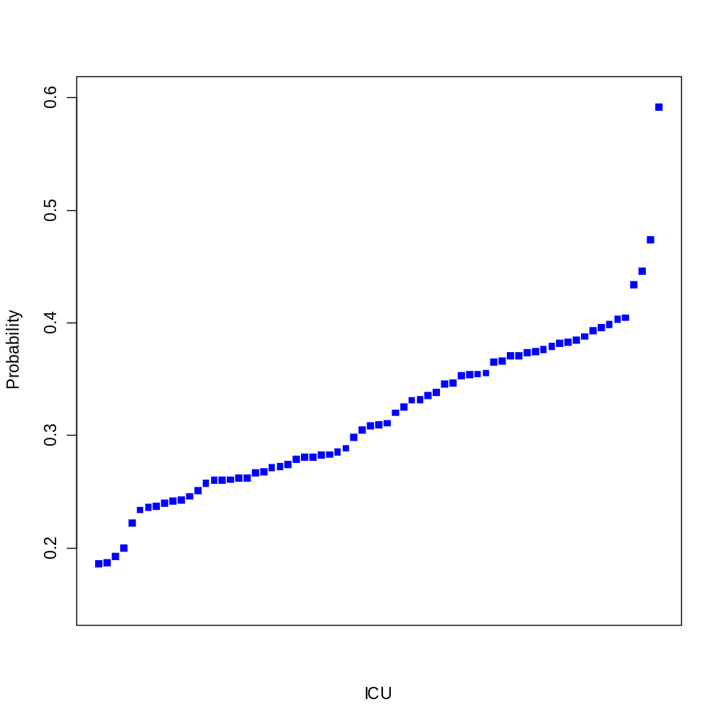
Figure 2. Proportion of patients who died in hospital.
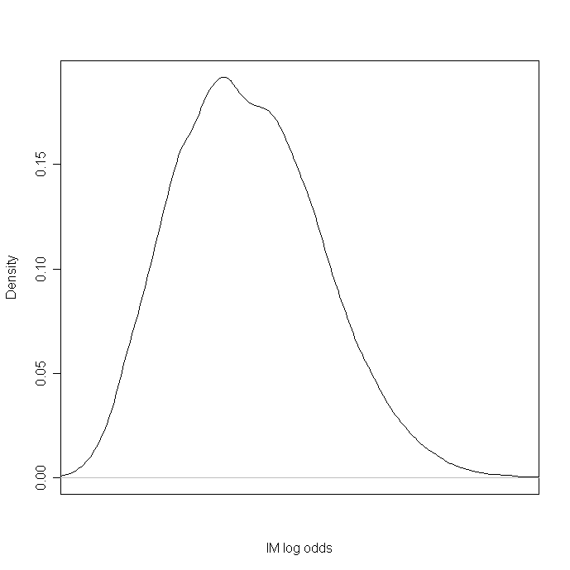
Figure 3. Plot of kernel density estimates of IMlo, using a bandwidth of 0.21.
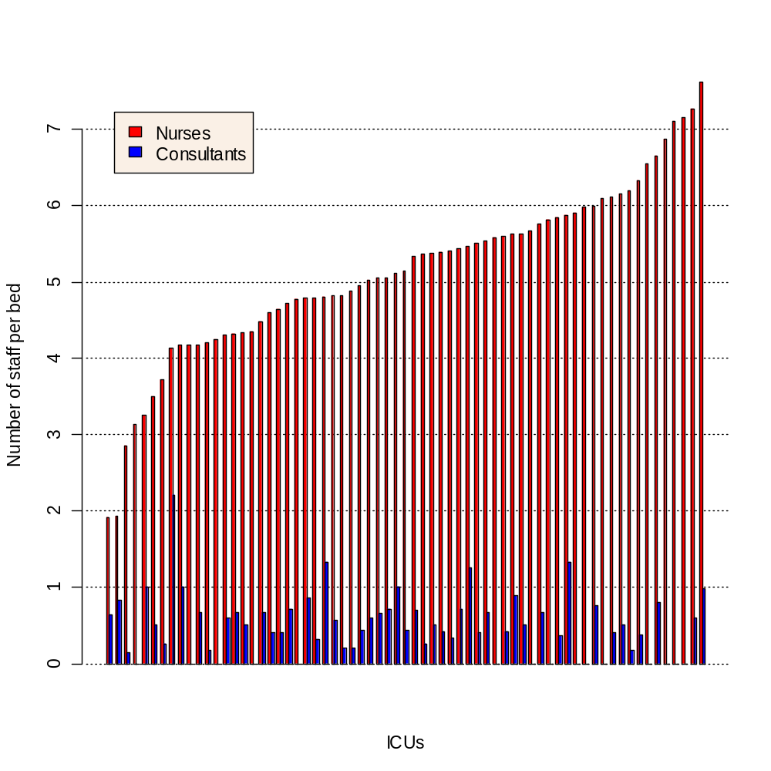
Figure 4. Bar plot showing the numbers of direct care nurses and consultants per bed in each ICU.

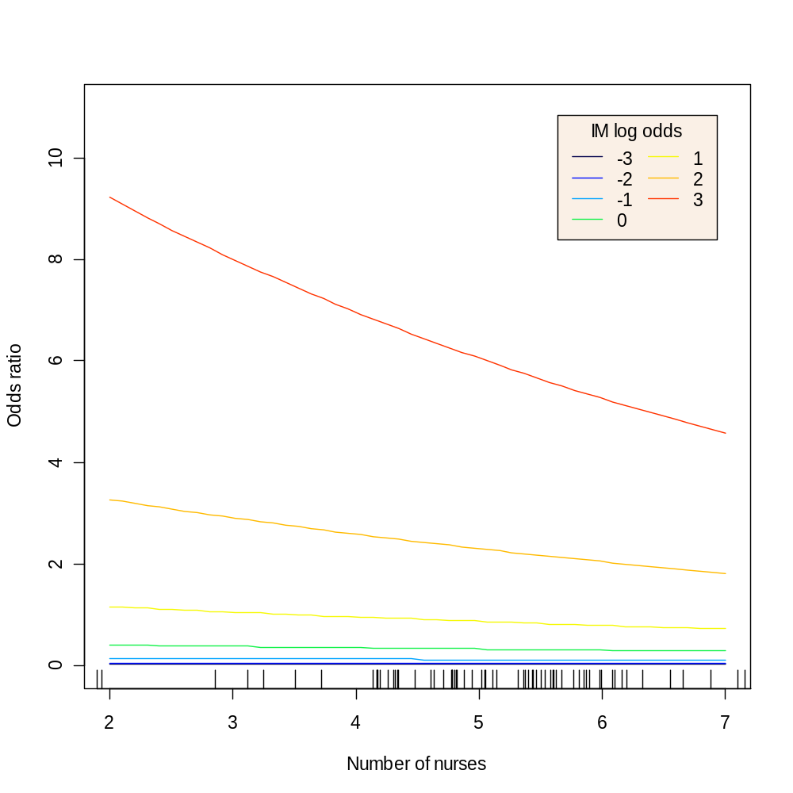
Figure 5. Estimated effect on the odds of mortality in the ICU of the number of direct care nurses in the unit for patients at different levels of risk as measured by the IM model, with a rug plot showing the distribution of observed values.

REFERENCES

1. West E, Sanderson C, Mays N, Rowan K. Nursing Resources and Patient Outcomes in Intensive Care: A Systematic Review of the Literature. 2006.
2. Tarnow-Mordi WO, Hau C, Warden A, Shearer AJ. Hospital Mortality in Relation to Staff Workload: A Four-Year Study in an Adult Intensive Care Unit. Lancet. 2000 15 July;356(9225):185-9.
3. Giraud T, Dhainaut JF, Vaxelaire JF, Joseph T, Journois D, Bleichner G, et al. Iatrogenic Complications in Adult Intensive Care Units: A Prospective Two Centre Study. Critical Care Medicine. 1993;21(1):40-51.
4. Robert J, Fridkin SK, Blumberg HM, Anderson B, White N, Ray SM, et al. The Influence of the Composition of the Nursing Staff on Primary Bloodstream Infection Rates in a Surgical Intensive Care Unit. Infection Control and Hospital Epidemiology. 2000;21(1):12-7.
5. Amaravadi RK, Dimick JB, Pronovost PJ, Lipsett PA. ICU nurse-to-patient ratio is associated with complications and resource use after esophagectomy. Intensive Care Med. 2000 Dec;26(12):1857-62.
6. Dang D, Johantgen ME, Pronovost PJ, Jenckes MW, Bass EB. Post-operative Complications: Does Intensive Care Unit Staff Nursing Make a Difference? Heart Lung. 2002 May-June(3):219-28.
7. Dimick JB, Pronovost PJ, Heitmiller RF, Lipsett PA. Intensive care unit physician staffing is associated with decreased length of stay, hospital cost, and complications after esophageal resection. Crit Care Med. 2001 Apr;29(4):753-8.
8. Fidler V, Nap R, Miranda DR. The effect of a managerial-based intervention on the occurrence of out-of-range-measurements and mortality in intensive care units. J Crit Care. 2004 Sep;19(3):130-4.
9. Fridkin SK, Pear SM, Williamson TH, Galgiani JN, Jarvis WR. The Role of Understaffing in Central Venous Catheter-Associated Bloodstream Infections. Infection Control and Hospital Epidemiology. 1996;17(3):150-8.
10. Pronovost PJ, Dang D, Dorman T, Lipsett PA, Garrett E, Jenckes MW, et al. Intensive care unit nurse staffing and the risk for complications after abdominal aortic surgery. Effective Clinical Practice. 2001;4(5):199-206.
11. Thorens JB, Kaelin RM, Jolliet P, Chevrolet JC. Influence of the quality of nursing on the duration of weaning from mechanical ventilation in patients with chronic obstructive pulmonary disease. Critical Care Medicine. 1995;23(11):1807-15.
12. Vicca AF. Nursing Staff Workload as a Determinant of Methicillin-Resistant Staphylococcus Aureus Spread in an Adult Intensive Therapy Unit. Journal of Hospital Infection. 1999;43(2):109-13.
13. Burchardi H, Moerer O. Twenty-four Hour Presence of Physicians in the ICU. Critical Care. 2001;5:131-7.
14. Pronovost PJ, Angus DC, Dorman T, Robinson KA, Dremsizov TT, Young TL. Physician staffing patterns and clinical outcomes in critically ill patients: a systematic review. Jama. 2002 Nov 6;288(17):2151-62.
15. Audit Commission. Critical to Success: The Place of Efficient and Effective Critical Care Services Within the Acute Hospital. London: Audit Commission; 1999.
16. Carmel S, Rowan K. Variation in intensive care unit outcomes: a search for the evidence on organizational factors. Curr Opin Crit Care. 2001 Aug;7(4):284-96.
17. Jones J, Rowan K. Is there a Relationship between the Volume of Work Carried out in Intensive Care and its Outcomes? Int J Technol Assess Health Care. 1995 Fall;11(4):762-9.
18. Goldfrad C, Rowan K. Does "Practice Make Perfect"? Volume of Work and Outcome in Intensive Care (Abstract). Journal of Epidemiology and Community Health. 2000:A9.
19. Goldfrad C, Rowan K. Consequences of discharges from intensive care at night. Lancet. 2000 Apr 1;355(9210):1138-42.
20. Bastos PG, Knaus WA, Zimmerman JE, Magalhaes A, Jr., Sun X, Wagner DP. The Importance of Technology for Achieving Superior Outcomes from Intensive Care. Brazil APACHE III Study Group. Intensive Care Medicine. 1996 July;22(7):664-9.
21. Shortell SM, Zimmerman JE, Rousseau DM, Gillies RR, Wagner DP, Draper EA, et al. The Performance of Intensive Care Units: Does Good Management Make a Difference? Medical Care. 1994 May;32(5):502-25.
22. Rowan KM. Outcome Comparisons of Intensive Care Units in Great Britain and Ireland Using the APACHE II Method. Oxford: University of Oxford; 1992.
23. Harrison DA, Brady AR, Parry GJ, Carpenter JR, Rowan K. Recalibration of risk prediction models in a large multicenter cohort of admissions to adult, general critical care units in the United Kingdom*. Crit Care Med. 2006 Mar 21.
24. R Development Core Team. R: A Language and Environment for Statistical Computing. Vienna: R Foundation for Statistical Computing; 2006.
25. Bates D, Maechler M. Matrix: A Matrix Package for R. 2006.

Very similar results to those reported here are obtained if this variable is replaced by one that counts the number of notional half days or by a dummy variable that identifies those units that have any consultant NHDs at all.
These calculations all use the mean values of variables with statistically significant regression coefficients, and exclude variables with non-significant regression estimates.

